\
CENTRE FOR COMMUNITY INITIATIOVES AGAINST HUMAN TRAFFICKING (CIAHT)

REPORT ON 30TH JULY,2026, INTERNATIONAL DAY CELEBRATION OF ANTI-HUMAN TRAFFICKING CAMPAIGN IN THE TOLON DICTRICT, KUMBUNGU DISTRICT AND SAGERIGU MUNICPAL OF THE NORTHERN REGION OF GHANA.

Theme: {Trapped behind the Scam}: Protection vulnerable persons from Human Trafficking in the digital age.
SUPPORT: TALITHAN-KUM GHANA AND SCA TO FIGHT AGAINST HUMAN TRAFFICKING IN THE STATES OF THE GULF OF GUINEA

FROM THE 28TH FEBRUARY TO 4TH August, 2026

CIAHT: Prepared by Child rights Advocacy officer: Date: 6th August,2026.

THE CONTEXT OF THE REPORTING OF THE ACTIVITIES
Acknowledgement …………………………………………………………………..3

Summary ………………………………………………………………………….…4

Kunguri / Nyujagyili Durbar……………………………………………………5– 9

Tinbung Durbar …………………………………………………………………10-14

Gbanlahi Durbar……………………………………………….………….…….. 15-17

Remarks on the durbars……………………………………………………………18-20

Photo gallery ………………………………………….…………………………..21-22

ACKNOWLEDGMENT
Our special thanks to Almighty God for the gift of life approved to celebration this 30th June,2026.
We appreciate the Talithan-kum Ghana and Safe Child Advocate for their financial assistance towards this year international day anti-human trafficking celebration
We appreciate the Department of Gender, Children and Social Protection from Tolon District, Kumbungu District and Sagnerigu municipal assembly for their fully involvement of this year international day celebration.
We thank the National Commission of Civil Education from Kumbungu District, Tolon District and Sagnerigu municipal assembly of their fully involvement for this year international day celebration.
We also appreciated the Department of Social Welfare and Community Development for their engagement Sagnerigu municipal assembly, Tolon District, Kumbungu District for this year international day celebration.
We thank the each five (5) Sub-chiefs and their elders from the three (3) communities in the three electoral area for their support and presence in the durbars.
Finally, we appreciate the effort of all Staff of CIAHT for their commitment throughout the process of the inception meetings with electoral areas assembly members, unit committee members, and Community Child Protection Committee (CCPC) or Community Paralegal Facilitators (CPF) for this year anti-human trafficking celebration in the three selected communities’ through organized communities’ durbars and radio discussion to mark this year international day celebration.

SUMMARY OF THE CELEBRATION ACTIVITIES
On 26th to 30th Jane 2026, CIAHT, started this year international celebration activities action plan by submission of request letters for organized community durbar in Kunguri-Nyujagyili to Tolon District Chief Executive, Ghanlahi in the Sagnerigu Municipal and also Tibung in the Kumbungu District and also National Commission of Civil Education, Department of Social Welfare, and Department of Community Development officers.
On 6th July, 2026, CIAHT organized separate inception meetings with Tolon District Chief Executive. At the meeting the Chief Executive assure us of his support and also called for more project for the district, He said, as an administer we needed financial support to enable assemble function very well. we hope next year celebration you will token to your donors to support the assembly with financial support to undertake public education in the District on child trafficking, early and force marriage cybercrime. He said our doors are well open for development projects engagement to enhance development in the District.
The same date CIAHT held meeting with National Commission of Civil Education, Department of Social Welfare, and Department of Community Development officers. The departmental head assured us of their readiness to move with us to educate the communities members and also, they asked for partnership with CIAHT to identify developmental issues that need urge attention as such youth Gender based violence, cybercrime, youth in human trafficking scam, streets connected children and youth in drugs.
On 20th July 2026, CIAHT staff held meeting with three electoral areas assembly members for planning and execution of the key issues such as inception meetings with community chiefs and opinion leaders to select a suitable date and time. It was agreed that CIAHT staff would meeting the assembly members at their electoral areas for engagement of the selected communities chief and opinion leaders. Below is the details:
1: Kunguri/Nyujagyili date of the durbar 30th July 2026, Time 9.00am to 12.00pm
2: Tinbung community date 31st July and time 10.00 to 1.00 pm
3; Gbanlahi community date 4th August,2026 and time 8.30 am to 12.30pm
The above-mentioned activity executed very successfully and all three. communities had given blessing to the event and called for partnership in their respective community development.

CIAHT CELEBRATED THIS YEAR ANTI-HUMAN TRAFFICKING INTERNATIONAL AT KUNGUR/NYUJAGYILI COMMUNITY
All schedule dates and time were fulfilled, the resource person and CIAHT staff were in the community ahead of the starting time of the celebration event.
What went good in the event:
- The choice of language; the use of the local dialect (Dagbani) made the durbar very participatory, interesting and engaging and it would be used for awareness creation at the any durbars, one on one engagement, peer education to any everybody on the negative effects of been trafficked.
- The use of the cultural dance in the event, made it lovely and entertaining.
- The use of the media was great and necessary because it is a means to propagate the fight against Human Trafficking and also improve community roadless to end human trafficking.
- The engagement of the all communities’ sub-chiefs, opinion leaders, women leaders and youth leaders to attended the durbars and participate fully in the celebration which had evidence that they will own the anti-human trafficking campaigned in their respectively communities.
The Impact of The Durbar:
- The people are well informed of the human trafficking syndicates.
- The readiness to support para-legal facilitator in the community to tackle the menace.
- The community members feel part in decision making for the even celebration.
- The reduction illegal migration to down south to seek for non-existing jobs and failed to human traffickers’ network.
- To encourage young youth to stay in the education ladder and learn vocational skills training for the development of their talents and creativity for self-empowerment
CIAHT, Established Community Para-Legal Facilitators
On 24-to 27 July 2026, CIAHT Human rights project officers visited Ghanlahi, Kunguri/Nyujagyili and Tinbung and held discussion with the selected para-legal facilitators, Assembly members and the Unit Committee Members. The meetings were used to sensitise them on the mission and vision of the organization and inauguration of the para-legal facilitators to fight against human Trafficking international day celebration.
On the celebration day, fourteen (14) members of Community Para-legal Facilitators (CPF) were sweated into office in each of the three respectful communities, they included Unit Committee Members, women group, youth group and the Assembly-representatives. The Community Para-legal Facilitators (CPF) were selected based on proportional ratio of women to avoid gender bias.
They were sensitised on Child trafficking/Child marriage, and its effects on both male and female children. The intention is for the abolishment of any form child trafficking/child marriage and its related issues in the Northern region and the country as a whole.
Centre for Community Initiative Against Human Trafficking (CIAHT) campaign to Eliminate human trafficking in the selected communities through grassroots sensitisation and Capacity building training had kicked started in the Kunguri/Nyujagyili which is made of two (2) communities. Prior to the set date of the durbar, on the 30th June, 2026, two staff of CIAHT and the Assemblyman of the area visited the community to reminded the Chiefs, elders and people from the suburb community to the event. All the Traditional Chief and Opinion leaders welcomed the mission and vision of the celebration, hence assuring their presence at the durbar.
The durbar began at 9:30 am at Kunguri Primary School, all the two (2) reigning chiefs of the involved communities’ members were present with their elders, so as the people from their communities.
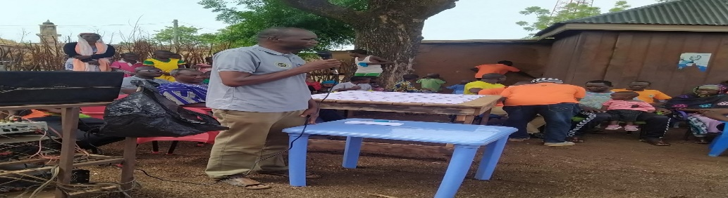
The Director of CIAHT Mr. Abdulai Danaah, made passionate appeal to the chiefs, opinion leaders’ women and youth groups at the durbars ground that to stop sending their children to cities of Ghana to look for non-existing jobs, let us encourage our children to stay and use their talents to create innovative ventures and seek for philanthropic assistance, development agencies and Government of Ghana to growth their business this would help to combat poverty.
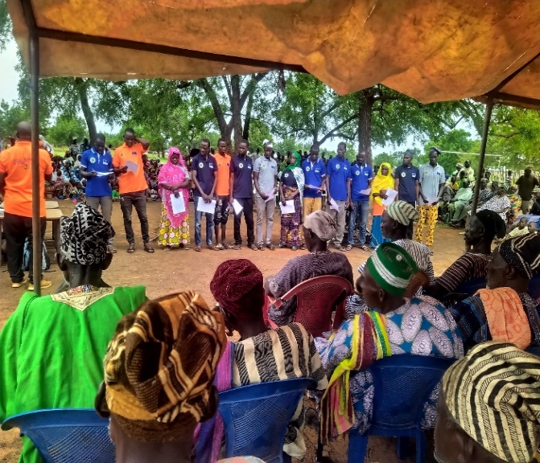
Abdulai Danaah Executive Director (CIAHT has said the establishment of Community Para-legal Facilitators (CPF) and its main duties is to engage entire community members on Child trafficking and child early and force marriage related issues within the communities and also set-up to help facilitate the developmental project activities. It is made-out of the Unit Committee Members, the Assembly member, women and youth groups. The CPF where told, during the training by resource persons on their duties they are expected to perform. They are to abide by the constitution and rules of the Community Para-legal Facilitators (CPF) and collaborate with existing Community Child Projection Committee to execute their functions. The Executive Director of (CIAHT) administered the Oath of service of the Community Para-legal Facilitators (CPF) members
Kunguri /Nyujagyili Para-legal facilitators
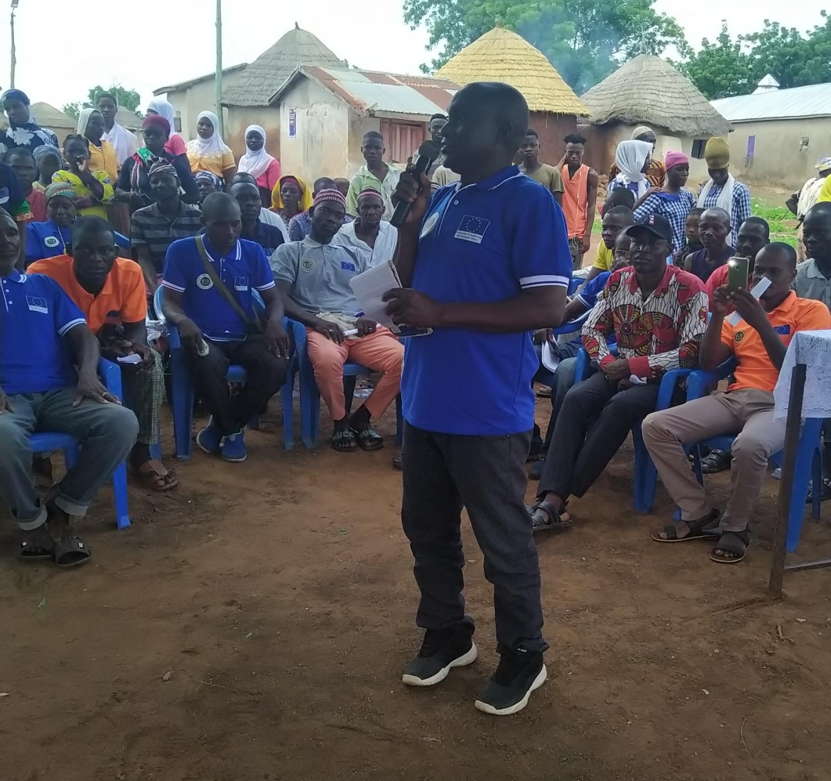
The representative from the National Commission for Civic Education (NCCE) Mr. Alhassan Abukari (Simple) took turn on the sensitisation, since it is part of their mandate to inform and educate. He introduced his office to the people as they work to promote and sustain democracy. He assigned discuss topic ,“Future of the youths today”. He talked of the repercussions of the current behaviours adopted by the youth to the future of the communities. He encouraged that, the get involved in productive activities and stop the deviant acts.
Mr. Alhassan Abukari, From National Commission for Civic Education (NCCE)
Representative from the Ministry Gender, Children and Social Protection Mr. Sumani Adam, was invited speak on “Internal migration and it’s link to human trafficking “. He elaborated on the rise in human trafficking the country and Africa as whole. Means of recruiting victims of trafficking are; deceit, recruitment, family relations
- The kingpin of trafficking target youth and lure them with deception on benefits of some opportunities which does not exist. Some of these victims ignorantly fall prey only to realise when it’s late.
- Recruitment scam; some victims are lured with the excuse of favourable job opportunities at the cities, only to be used for prostitution and child labour activities. The participants are advised to thoroughly investigate and information about job before attending for employment to avoid becoming casualty. The recruitment scam is a whole syndicate which needs to be looked at or addressed.
- Family relations; some children are given to family relations as aid in domestic chores as cultural beliefs. But some of the children become victims of child labour, abuses and forced into prostitution. He discouraged this act and advised the children are put in school and put to learn vocational skills.
The CCPC Members were Sworn-In by a representative from the Office of Social Welfare Mr. Alhassan Abukari. He advised they abide by the constitution of the country and practice the training to be given them by the resource persons, for effective running of the project. Their activities should be void of political differences, because it is not a political project but a social project.
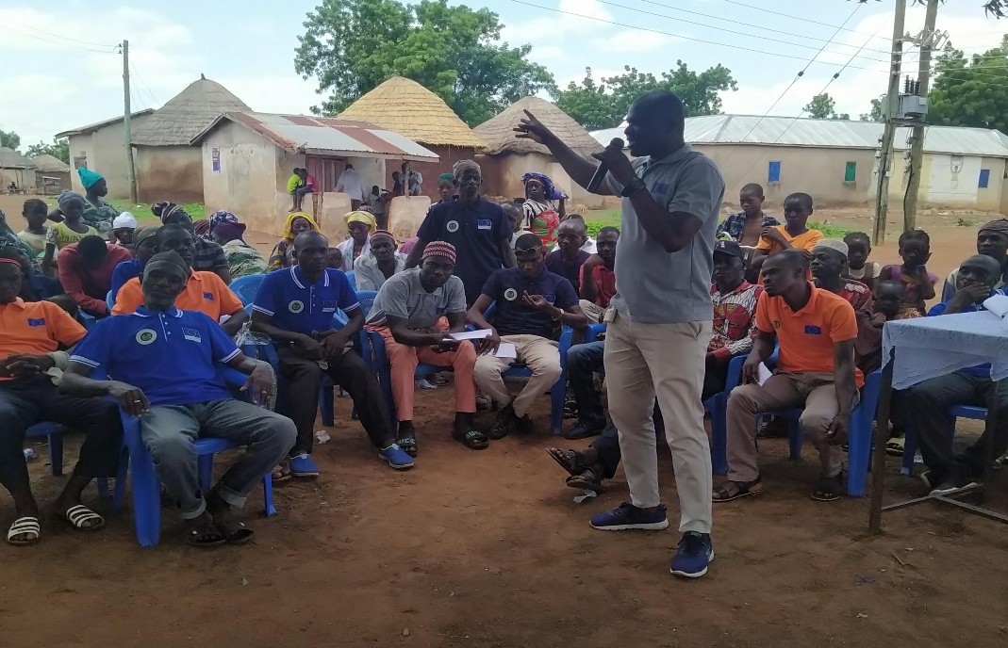
The Durbar was climaxed with prayer from the pastor of the Kunguri community.
Mr. Sumani Adam, Ministry Gender, Children and Social Protection

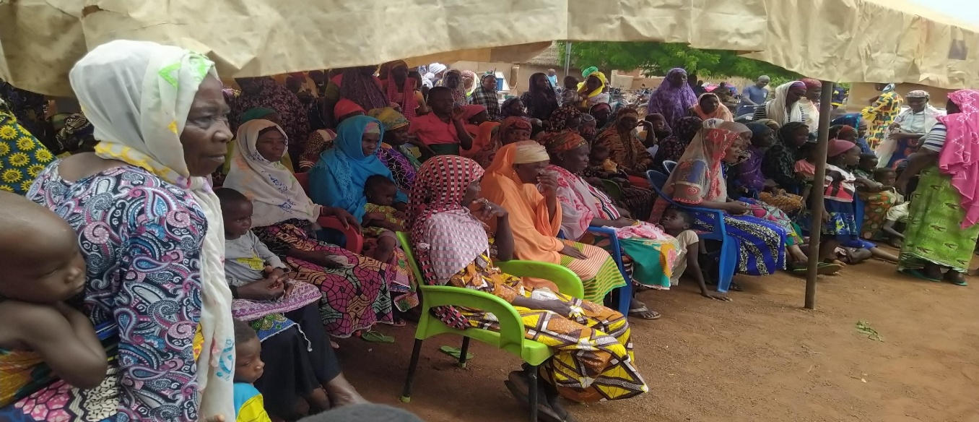
GALLERY FROM WANTUGU COMMUNITY DURBAR
Women and children of Wantugu Electoral Area

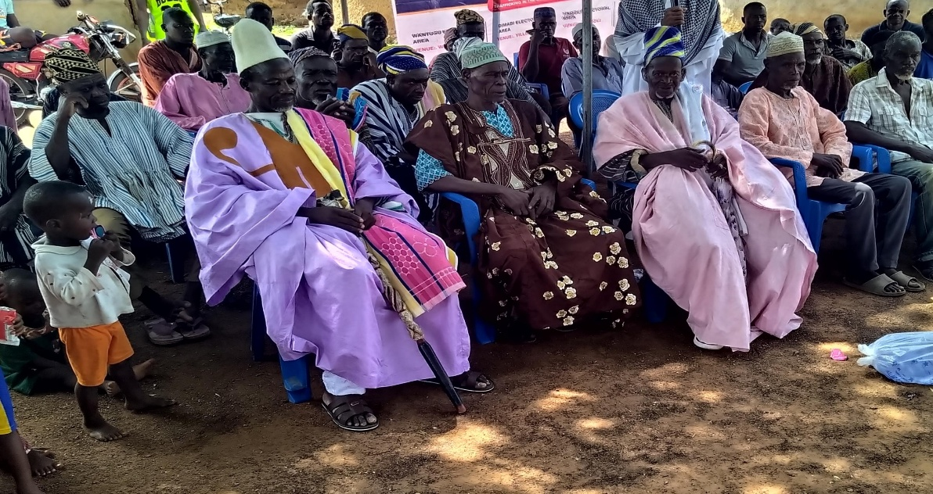
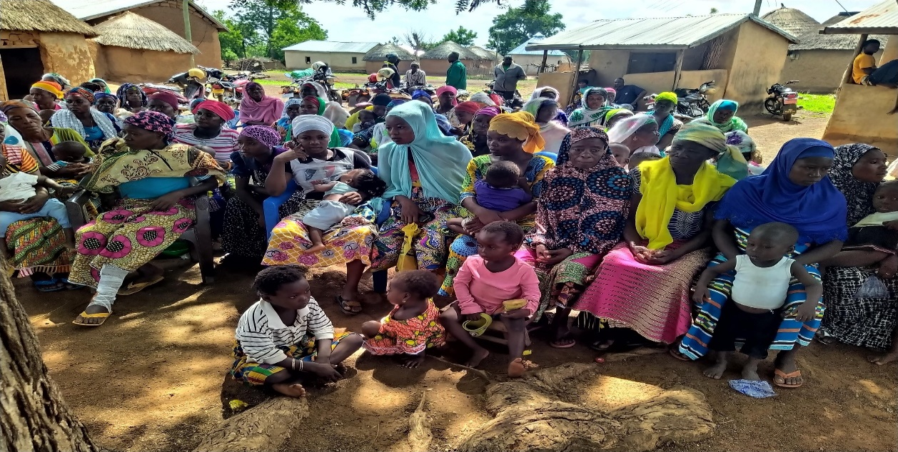

REPORT ON TINGUNG COMMUNITY DURBAR
02nd AUGUST, 2026 AT TINBUNG D/A PRIMARY SCHOOL.
The opening prayer was given by the Imam of the Tinbung community.
Mr. Sulley Karim (Assemblyman) of Tinbung electoral area gave the opening remarks and introduced the Chairman to steer the affairs of the programme. He acknowledged the presence of chiefs from the various communities;
The Chairman was Naa Ziblim Niendow (Bombom-Naa) from the Kunguri community. He accepted the responsibility and acknowledged all members present at the Durbar. He gave his full support to the activities to be carried by CIAHT in his community.
A member of CIAHT Board of Directors, Dr. Alhassan John Nabia addressed the people about CAIHT and its motive to combat human trafficking in Ghana. He first of all appreciated the director of CIAHT and his zeal towards the project.
Dr. Nabia agreed that migration by people from the north to south of Ghana has been happening since the past, but it was done by the matured people for economic benefit for feed their families. Unlike now, the people involved in this migration are children of all gender, some with or without the consent of their parents.
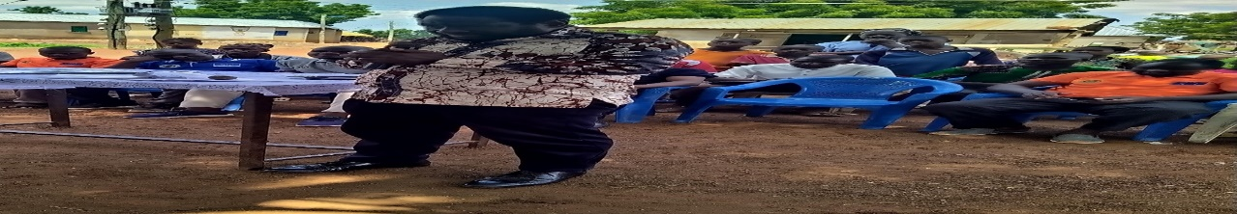
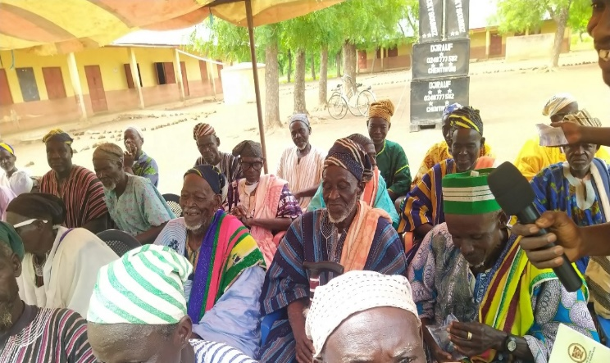
Dr. Nabia emphasized on the hidden poor livelihood conditions the people who travel for kayayie or are being trafficked are faced with. He echoed the fact that some of the people who involved do not say a truth of the challenges they face in their hustle unless in becomes critical
Chairman was Naa Ziblim Niendow (Bombom-Naa) Dr. Alhassan John Nabia

The Warriors (SAPASHINI) of the Kunguri performed the Sapashini dance for the entertainment of the crow.
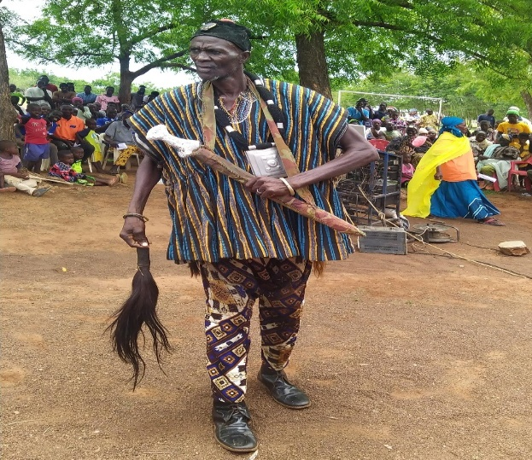
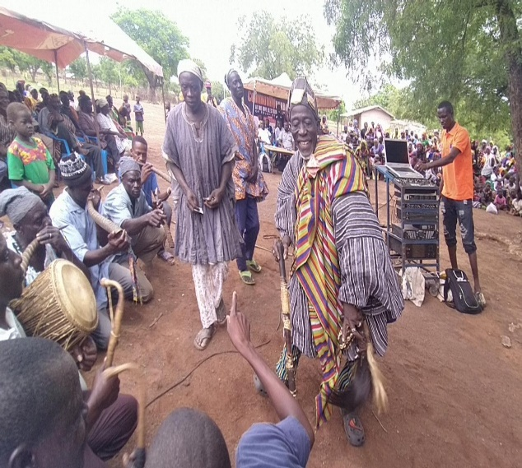
Cultural performance of Sapashini Dance Chief Dancer ( Sinya Dramani)
NCCE Representative Mr. Alhassan Abukari Simple addressed the crowd on the future of the youth/Children. He talked of the rising insecurities and the government’s initiative “See something say something “thus, when am individual sees someone or something strange in their communities, the should report to appropriate authority or CIAHT office immediately.
He admonished the social inclusion of the children in decision and giving the youth support in all they do and advised when they go wrong, but not scolds.
We should keep check on the behaviour of our children or youth for they are the future of the various communities. So let support the children and youth in good decision making.
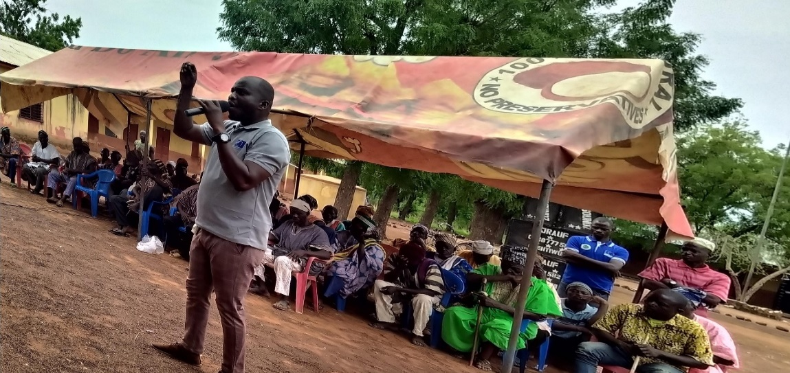
Mr. Sumani Adam, From Ministry of Gender, Children and Social Protection
Mr. Sumani Adam from the Ministry of Gender, children and social protection talked on how some migration leads to human trafficking. He admonished, the migrants are mostly vulnerable and desperate for any work which usually leads them to being victims of trafficking.
He talked of the use of illicit drugs by the youth and its consequences to their future. He talked of the insurgence of teenage pregnancies and sicknesses as a result of the migration and trafficking.
The Community Para-legal Facilitators (CPF) members were Sworn-In by Mr. Adam Imoro, an official from Social Welfare Department. He encouraged they uphold and defend the responsibility given them for the development of their communities. This will help mitigate or stop human trafficking in Ghana, hence the world. They CPF should work in partnership devoid of political talks.
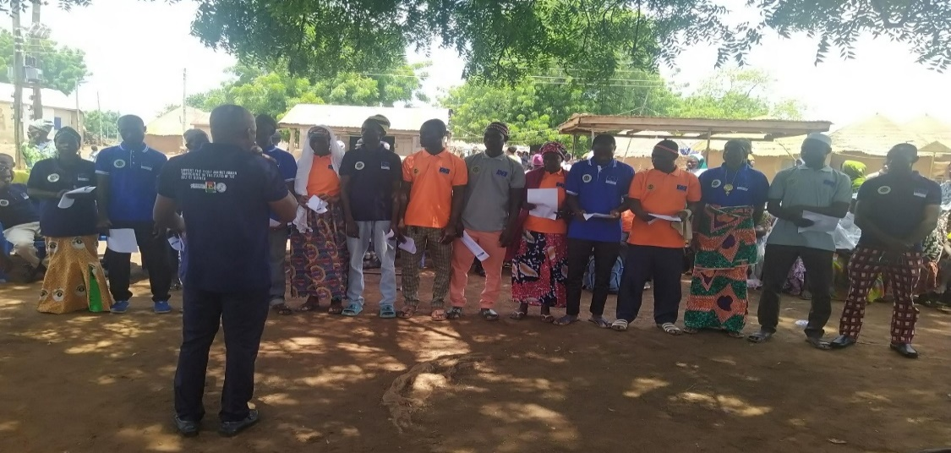
The Representative from the office of Department Social Welfare led the members of the CPF into taking their oath of service. He advised the CPF to collaborate with the existing CCPC to hold dearly to the duties ahead of them, for the development and growth of the communities.
The Chairman applauded information delivered to them above the insurgence of human trafficking in Ghana. He said slavery is a thing of the past and do not encourage his people be victims to it. Some participants in the durbar were called to give their taught. The Chief of Kangbagu Kpanalana a native from the communities gave his remarks on the even and applauded its existence. He testified a deceit his family had about house help job for three of his daughters and at the end, they (children) were used for slavery by the woman.
Madam Musah Safarawu volunteered to speak and recounted the struggles she went through when she was at kayayo.in Accra 2021 She also pleaded with their husbands to be patient in handling issues when the children run for Kayayo, because she was accused by her husband when their daughter ran to kayayo, when she had no idea for her going to the south.

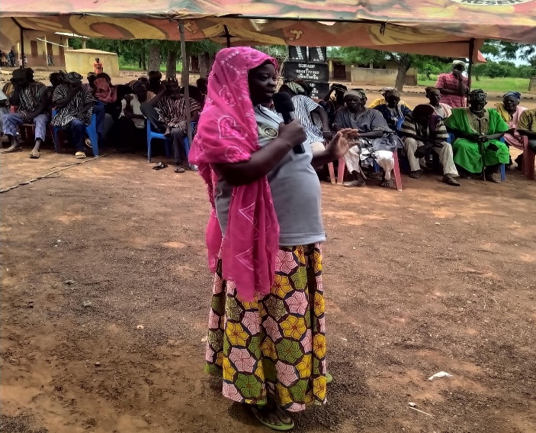
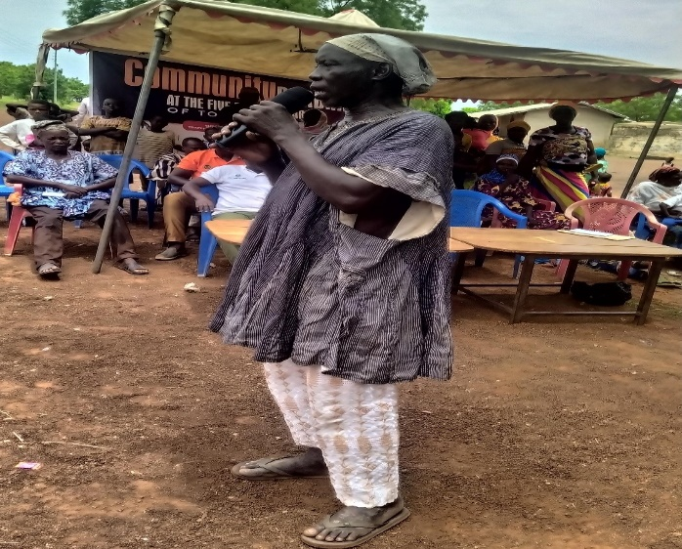
.
Madam Safarawu
Kangbagu Kpanalana

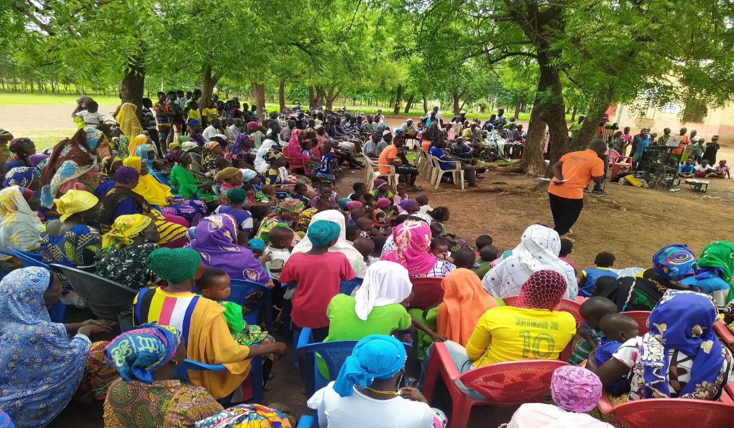
GALLERY FROM THE KUNGURI/NYUJAGYILI DURBAR
Women and children of Kunguri/Nyujagyili electoral area

Tinbung Session of the grand community durbar
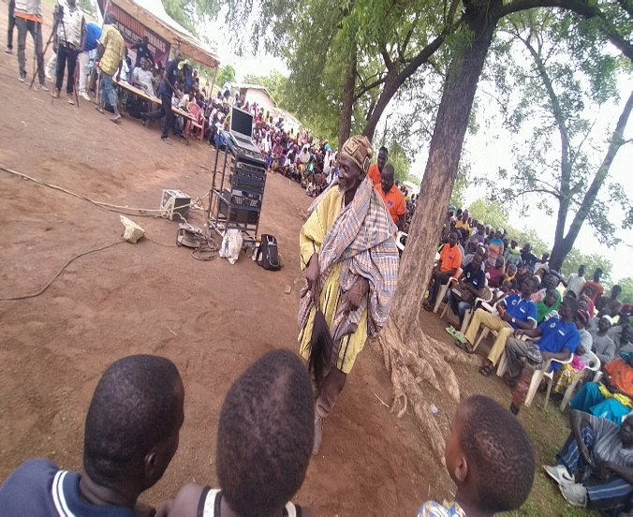
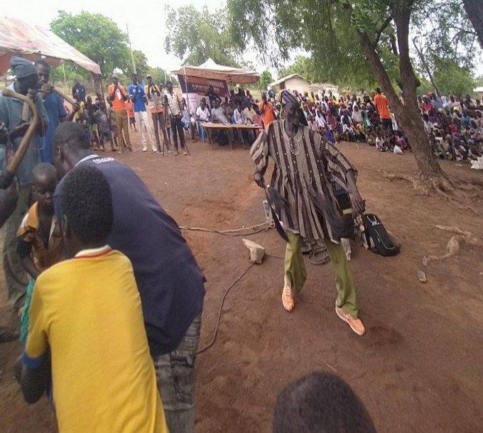
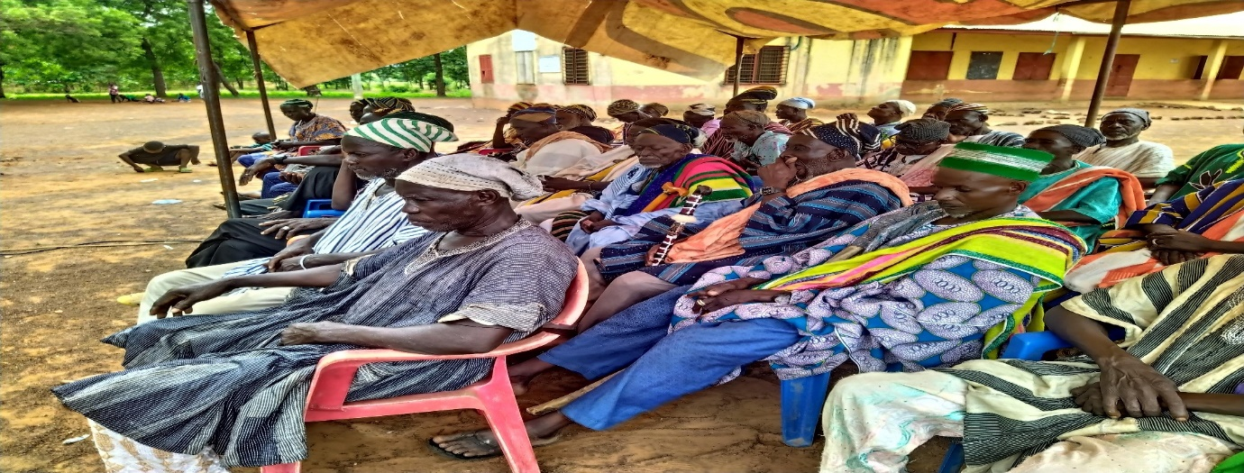
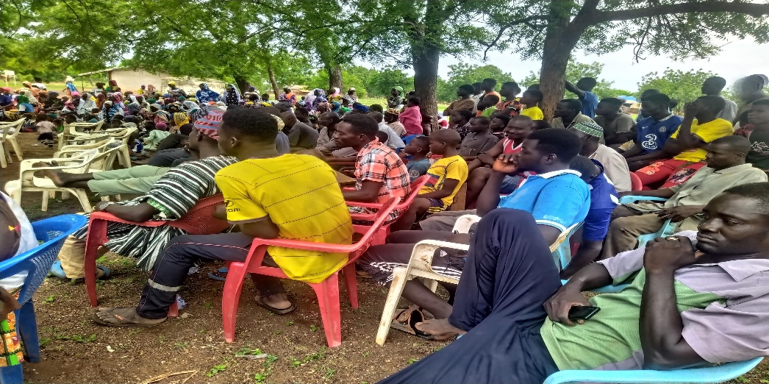
Chief and the elders of the communities

Report on Ghanlahi community
04th August 2026 at Ghanlahi community Chief’s Palace.
The Chief Imam of Ghanlahi community gave an opening prayer to commit the Durbar to God.
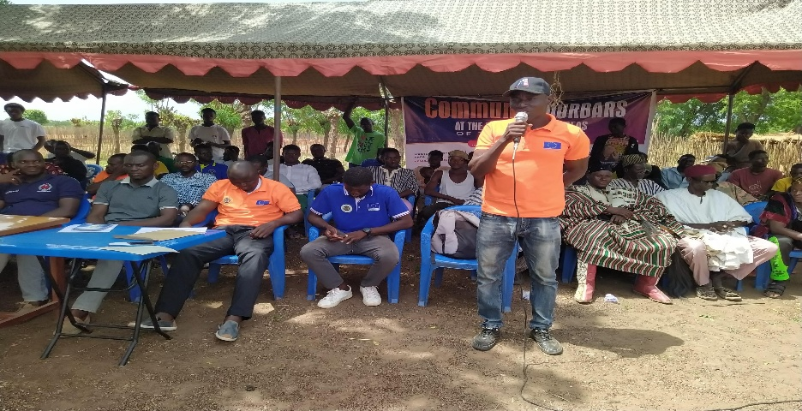
Mr. Baako Baba the assemblyman of the electoral area welcomed the people to the Durbar appreciated the people present and the Chiefs;
The chairman as introduced by the assemblyman is Naa Abdulai Naporo (Ghanlahi Chief)
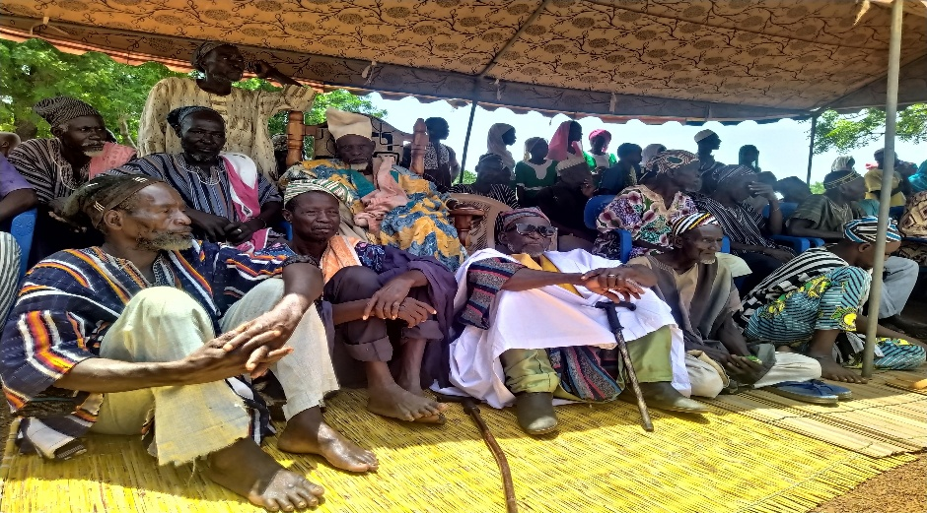
Naa Abdulai Naporo – Chairman of the Durbar

The Chairman received the honour with appreciation and encouraged his subjects to accept the project with all seriousness for the growth of Ghanlahi and its environments.
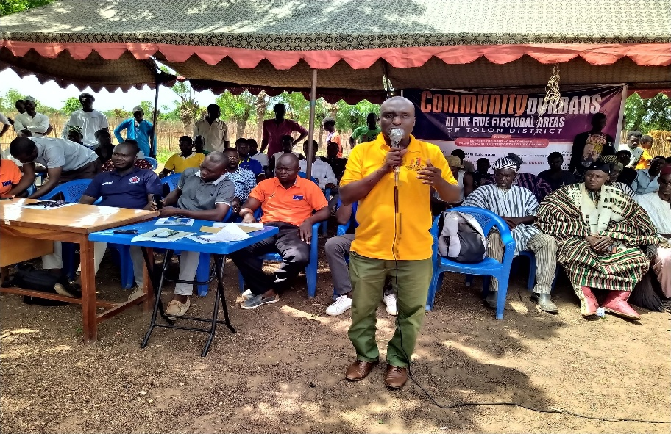

Speech by NCCE officer Mr. Alhassan Abukari Simple, who spoke on the “future of the youth” in the various communities. He educated the people on the mandate of NCCE to the people and how they can be contacted.
- He advised the parents to ensure their wards do not keep up late at night because it reduces their productivity in the day.
- The importance of education (formal and non-formal) was discussed with the people.
- The rising if cyber fraud in the country and how to avoid being victims was discussed with people in the communities.
The durbar was again address by Mr. Sumani Adam, an official from Ministry of Gender, Children and Social Protection. He spoke on unapproved migration among the youth and the people from the Northern part of Ghana. He made it clear that most of the illegal migration has more negative impact than the few monies some will get.
He encouraged that the youth appreciate what they have in their communities. The value of anything depends on what it is used for. Agriculture is very beneficial but need dedication and hard work. They are therefore entreated to venture into agricultural activities for food sustainability and economic benefit.

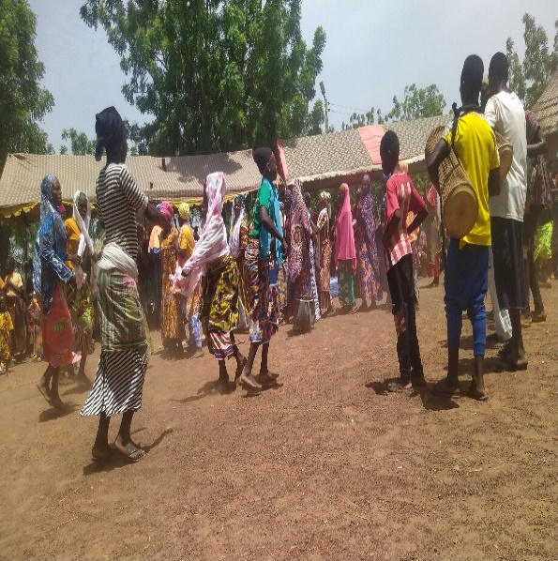
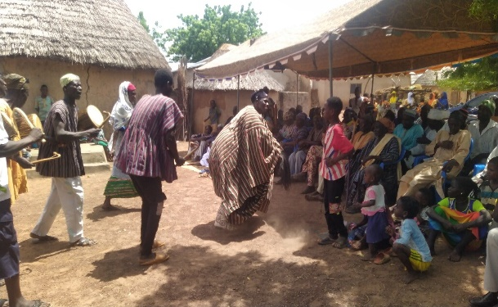
The cultural Performance Group entertained the Durbar with “Takai and Torrah dance”.

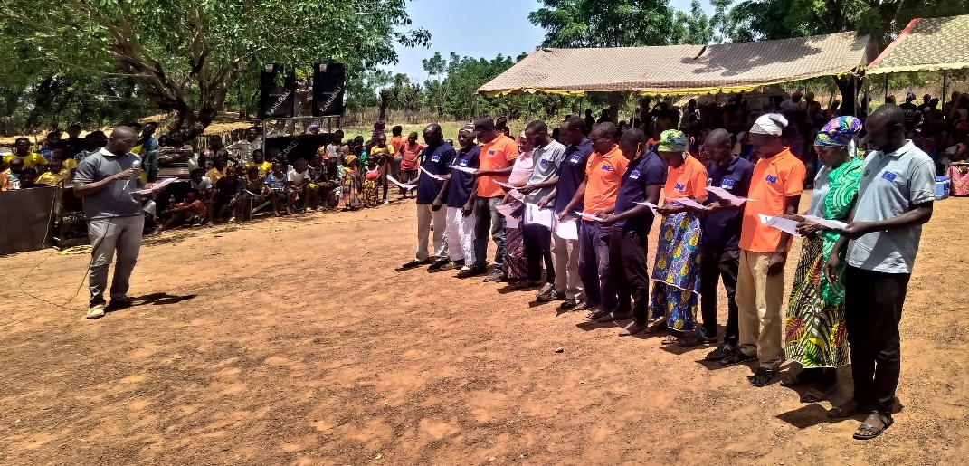
The CPF members were Sworn-In by Mr. Imoro Adam from social welfare department. They were advised to uphold and defend the office of the CPF and also must collaborate with the existing Community Child Protection Committee (CCPC).
Swearing -in of CPF members by Mr.Adam Imoro

Mr. Mohammed from Wovo-guma took the podium to appreciate the effort of CIAHT to sensitise them of human trafficking, they did not believe it existed until they were informed
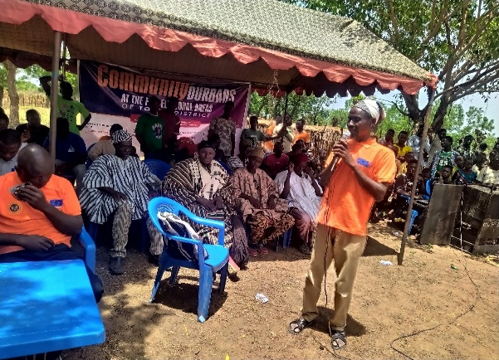
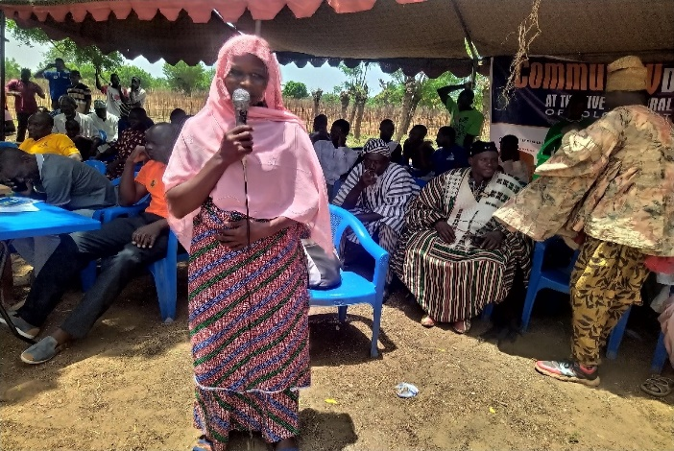
Madam Abdulai Zuwera also appreciated the inclusion of women in the development of their communities.
Mr. Mohammed – men’s representative from Ghanalahi
Abdulai Zuwera – women representative from Wovo-guma

The Representative of the NCCE applauded CIAHT and the initiative for the platform to educate and inform community people. He encouraged youth development for they are future of the communities. Parent were advised to practice these measures with their children to prevent them from falling victims human trafficking;
  - Children should be encouraged not to keep-long at night especially after 9:00pm
  - Let build good friendly relationship with the children or youth to build trust among the family.
  - Let not force skills on trade to the children.
  - The youth should know that opportunities can be created in our local communities.
Mr. Abubakari, the Assemblyman of the electoral area was appointed by the Chairman to give closing remarks of the durbar. He encouraged full participation of all from the various communities for social development.

POST CELEBRATION ASSESSMENT
What went wrong with the Durbar?
- There was delay in the release of funds.
- Late start of the programme due to community chiefs and elders delayed to the events
- Inadequate sitting chairs arrangement for the participants
Way forward to address the challenges;
- Quick release of funds
- CIAHT team should release funds to CPF to organize the durbars
- The CIAHT staff should encourage to be resources persons members.
What went good in the programme;
- The choice of language; the use of the local dialect (Dagbanli) made the durbar very participatory, interesting and engagement.
- The use of the cultural dance in the programme, made it lovely and entertaining.
- The presence of the communities Chiefs and Governmental departments made the people feel inclusive and important. The people of the communities do not usually have government officials if not during political campaigns. With the presence of the visitors through the durbar increased their trust in the project.
- The use of the media was great and necessary because it is a means to propagate the fight against Human Trafficking and improve community development.
- The engagement of the Chiefs and other leaders in the durbar. People from local communities will only participate fully in a project if it has the support of their chiefs. With the presence of the custodian of their lands, they are fully willing to be part of the project.
LOGISTICS
- The request for T-shirts by traditional chiefs and opinion leader
- The attendance to the events was good because all the invited people were present at the time.
PUBLICITY
The durbars had a good coverage to all the internal and external people of the communities. The plan and execution of the event was well structured to reach all the stakeholders in the fight against Human Trafficking.

EXPECTATIONS
What the community expects after the durbar;
- Provision of vocational skill training centre
- To carry out for the CPF members
- Regular awareness creation for communities’ members
- They expect agribusiness forums
- Digital business skills train centre
What CIAHT wants to achieve in the community;
- To create awareness on Anti- Human Trafficking and its effects.
- The cooperation of the communities members.
- The reduction youth migration and cyber fraud.
- Vocational Education skill and business development of the community’s people.
THE IMPACT OF THE DURBAR;
- The people are informed of the Human trafficking syndicates.
- The readiness of key actors to tackle human trafficking menace.
- The community members feel part in decision making of their respective communities.
PROCEDURE FOR THE SELECTION OF THE CPF
  - Community entering approach
  - Meeting involvement of the electoral area’s assembly members, Unit Committee members. women groups and youth groups
  - Inception meeting with the community’s chiefs and elders on the selection and formation of CPF.
  - Nomination open for only one month, interview letters given and conducted and selected CPF members given selection letters.
- Passion to be train as community paralegal facilitator
- Commitment for the community’s development
- Level of influence they have in the communities
- Hard-working, tolerance and integrity

Following-out after international day celebration
- Engage community member to identify community safeguarding prevent and protect human trafficking and early and force marriage.
- Capacity building training for the CPF members
- Enhance community durbars and educational institution awareness campaigns
- Organize CPF member on monthly monitoring and evaluation meeting to end human trafficking.

GALLERY OF THE CELEBRATION PHOTOS




